 | Epsom & Ewell F.C.  2  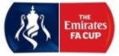  v  Beckenham Town  Tuesday, 28th August 2018 – 7.45 p.m.
Good evening and welcome to High Road for our Emirates F.A. Cup replay. We welcome the players, supporters and officials of Beckenham Town for the first time in nearly eight years.

Our last appearance here was last Tuesday against Chessington & Hook United, where we suffered the loss of our keeper Ricky Borrett to a red card after just nine minutes and trailed at the half by two goals. The ten men came out and worked much harder in the second half and pulled a goal back, but had to admit defeat for the first time this season by two goals to one. Then of course we bounced back well when we visited Beckenham Town on the Saturday and thoroughly deserved our 2-2 draw. Arguably we should have won based on our second half performance, but we know that as a Step Five team they remain favourites for this tie and we will need to play well again to have a chance of progressing.

As you might expect, the fixture situation is complicated at the moment with cup matches proving a pleasant distraction for our club. However, I am not a fan of Cup replays at all. In the later stages, I don’t see why some clubs should benefit financially from a draw and subsequent replay that they may lose, against a team that won first time out? Will we see the day when a non-league club is leading a Premier League club in the 90th minute, only to concede an equaliser to give them a lucrative replay instead? This might sound bizarre, but is not beyond the realms of possibility these days. Of course, the earlier rounds bring different issues. Replays provide short notice fixture congestion for Secretaries and problems for Programme Editors who then have two choices; either to put an issue together before the first tie that they may never need, or to wait until the match is drawn and then cram many hours in at short notice to create a readable hard copy issue, which we will always try to do here. Don’t get me onto the subject of online programmes!

At least we now know that our next match will be a visit to Lingfield in the Buildbase F.A. Vase on Friday 31st August, although it will be played at Whyteleafe FC as the Lingfield ground is not yet available due to cricket requirements. We then visit Whyteleafe again on Tuesday 4th September for a League match at their tenants AC London, assuming there is no Vase replay required; although if one was, it would be on Wednesday 5th September as Chipstead are at home on the Tuesday.

We are next due to be at High Road on Saturday 8th September when Cove visit for a League match, but if we progress tonight then the next round would of course take preference, wherever it may be. The draw was made this afternoon, so was too late for inclusion in the programme but will be announced tonight.

Please note that if the scores are level after 90 minutes, then extra time will be played and if still undecided then penalties would follow.

Enjoy the game!

Rich

You can follow us on Facebook: www.facebook.com/epsomandewellfc
Twitter: @EEFCOfficial Instagram at: www.instagram.com/epsomandewellfc
and Youtube at: www.youtube.com/channel/UCtLrpS0x5OaYUACRT34_zng

Cover photos by Gemma Jarman

- Taryn Smith scores our second goal at Bagshot in our 3-0 win on Saturday 18th August
- Taryn Smith scores our opening goal in the same match
- Liam Roberts scores our spectacular equaliser on Saturday at Beckenham Town


Cherry Red Records Combined Counties League
Division One Table 2018/19
inc Monday 27th August 2018 | P | W | D | L | F | A | Pts | GD | H | A
Bedfont & Feltham | 6 | 4 | 2 | 0 | 29 | 4 | 14 | +25 | 8/12 | 13/4
Farnham Town | 5 | 4 | 0 | 1 | 17 | 6 | 12 | +11 | 2/2 | 20/10
Dorking Wanderers Res | 5 | 3 | 2 | 0 | 13 | 7 | 11 | +6 | 27/11 | 11/9
Ash United | 4 | 3 | 1 | 0 | 15 | 6 | 10 | +9 | 12/1 | 10/11
Chessington & Hook Utd | 6 | 3 | 1 | 2 | 13 | 14 | 10 | -1 | 1-2 | 27/10
Sheerwater | 4 | 3 | 0 | 1 | 9 | 5 | 9 | +4 | 6/10 | 22/12
Sandhurst Town | 4 | 3 | 0 | 2 | 6 | 10 | 9 | -4 | 20/4 | 2-0
AC London | 4 | 2 | 1 | 1 | 10 | 8 | 7 | +2 | 2/3 | 4/9
Tooting Bec | 5 | 2 | 1 | 2 | 7 | 7 | 7 | 0 | 18/9 | 30/3
British Airways | 6 | 2 | 1 | 3 | 10 | 15 | 7 | -5 | 16/2 | 13/10
Epsom & Ewell | 3 | 2 | 0 | 1 | 6 | 2 | 6 | +4 | X | X
Eversley & California | 4 | 2 | 0 | 2 | 8 | 8 | 6 | 0 | 29/12 | 24/11
FC Deportivo Galicia | 6 | 1 | 2 | 3 | 8 | 7 | 5 | +1 | 12/3 | 22/9
Frimley Green | 3 | 1 | 2 | 0 | 3 | 2 | 5 | +1 | 3/11 | 23/2
Godalming Town | 5 | 1 | 1 | 3 | 5 | 13 | 4 | -8 | 1/12 | 26/1
Kensington Borough | 5 | 1 | 0 | 4 | 9 | 17 | 3 | -8 | 17/11 | 9/3
Bagshot | 4 | 1 | 0 | 3 | 3 | 19 | 3 | -16 | 19/1 | 3-0
Fleet Spurs | 5 | 0 | 0 | 5 | 5 | 15 | 0 | -10 | 6/4 | 29/9
Cove | 5 | 0 | 0 | 5 | 4 | 15 | 0 | -11 | 8/9 | 5/1

Lucky Day? – 28th August
Played 22 - Won 13 Drawn 4 Lost 5 - For 49 Against 32 - PPG 1.95 - Very Good
Our Club record against Beckenham Town (the modern club 1971-)
Played 5 - Won 2 Drawn 1 Lost 2 - For 11 Against 7 - PPG 1.40 - Average
Our Club record against Beckenham FC (the former club 1887-1969)
Played 9 - Won 7 Drawn 1 Lost 1 - For 37 Against 14 - PPG 2.44 - Fantastic
Our Largest wins and losses against the modern Beckenham Town
16th February 1988 - W 5-1 - London Senior Cup (A) - played at Epsom
30th December 2010 - L 2-3 - Surrey Senior Cup Second Round (H)
Beckenham Town’s Last Visit
30th December 2010 - Lost 2-3 - Surrey Senior Cup Second Round

First Eleven Appearances 2018/19 - (max 5)
Name | Debut | 2017/18 |  |  |  | Career Totals
Name | Debut | App | Sub | Tot | Goals | App | Sub | Tot | Goals
BENNETT Bobby | 12/08/2018 | 3 | 0 | 3 | 1 | 3 | 0 | 3 | 1
BETANCOURT Steve | 18/08/2018 | 3 | 0 | 3 | 0 | 3 | 0 | 3 | 0
BORRETT Ricky | 04/08/2018 | 5 | 0 | 5 | 0 | 5 | 0 | 5 | 0
CAMPBELL Kieran | 29/09/2012 | 5 | 0 | 5 | 0 | 57 | 0 | 57 | 0
CONNELLY Lloyd | 14/10/2017 | 5 | 0 | 5 | 2 | 35 | 4 | 39 | 4
ELGAR Luke | 04/08/2018 | 1 | 2 | 3 | 0 | 1 | 2 | 3 | 0
ELGAR Scott | 12/08/2018 | 1 | 3 | 4 | 0 | 1 | 3 | 4 | 0
GRIFFIN Reisse | 08/08/2015 | 3 | 0 | 3 | 0 | 107 | 13 | 120 | 8
HEAGNEY Adam | 16/08/2016 | 5 | 0 | 5 | 0 | 72 | 13 | 85 | 2
LOFTUS-CHEEK Joe | 06/08/2017 | 0 | 1 | 1 | 0 | 15 | 7 | 22 | 6
MCKAY Alex | 20/12/2008 | 1 | 0 | 1 | 0 | 163 | 39 | 202 | 13
MURPHY Scott | 20/01/2007 | 5 | 0 | 5 | 0 | 52 | 2 | 54 | 4
ROBERTS Liam | 12/08/2017 | 4 | 1 | 5 | 3 | 25 | 15 | 40 | 8
SMITH Taryn | 28/10/2017 | 1 | 4 | 5 | 4 | 9 | 8 | 17 | 4
SULLIVAN Ryan | 04/08/2018 | 4 | 1 | 5 | 0 | 4 | 1 | 5 | 0
SUTHERLAND Mitchel | 04/08/2018 | 1 | 1 | 2 | 0 | 1 | 1 | 2 | 0
THOMPSON Elliott | 09/02/2016 | 5 | 0 | 5 | 0 | 15 | 9 | 24 | 1
WHITE Sean | 02/08/2014 | 3 | 1 | 4 | 0 | 23 | 22 | 45 | 5

Recent Results and Fixtures
Combined Counties League – Tuesday 21st August
Ash United | 5-1 | Bagshot
Bedfont & Feltham | 0-0 | Frimley Green
Epsom & Ewell | 1-2 | Chessington & Hook Utd
Godalming Town | 2-5 | Dorking Wanderers Reserves
Sandhurst Town | 2-1 | Farnham Town
Combined Counties League – Wednesday 22nd August
British Airways | 0-0 | FC Deportivo Galicia
Emirates F.A. Cup – Extra Preliminary Round – Saturday 25th August
Beckenham Town | 2-2 | Epsom & Ewell
Lymington Town | 2-0 | Frimley Green
Combined Counties League – Saturday 25th August
British Airways | 6-1 | Cove
Chessington & Hook United | 2-0 | Tooting Bec
Eversley & California | 1-5 | Bedfont & Feltham
FC Deportivo Galicia | 1-3 | AC London
Godalming Town | 0-4 | Ash United
Kensington Borough | 0-3 | Farnham Town
Sandhurst Town | 2-1 | Fleet Spurs
Combined Counties League – Monday 27th August
AC London | 6-4 | Chessington & Hook United
Bagshot | p-p | Eversley & California
Bedfont & Feltham | 5-0 | British Airways
Cove | 1-2 | Sandhurst Town
Farnham Town | 3-1 | Godalming Town
Fleet Spurs | 1-2 | Dorking Wanderers Reserves
Sheerwater | 1-0 | FC Deportivo Galicia
Tooting Bec | 5-3 | Kensington Borough
Emirates F.A. Cup – Extra Preliminary Round Replay – Tuesday 28th August
Epsom & Ewell | V | Beckenham Town
Combined Counties League – Tuesday 28th August
Ash United | V | Frimley Green
Buildbase F.A. Vase – Friday 31st August
Lingfield | @Whyteleafe | Epsom & Ewell
Buildbase F.A. Vase – Saturday 1st September
Binfield | V | Frimley Green
Brimscombe & Thrupp | V | Ash United
British Airways | V | Harefield United
Chessington & Hook United | V | Oakwood
Cove | V | Fleet Spurs
Eversley & California | V | Downton
Recent Results and Fixtures
Buildbase F.A. Vase – Saturday 1st September
FC Deportivo Galicia | V | London Tigers
Sandhurst Town | V | Kensington Borough
Seaford Town | V | Tooting Bec
Westside | V | AC London
Wick | V | Godalming Town
Combined Counties League – Saturday 1st September
Dorking Wanderers Reserves | V | Farnham Town
Buildbase F.A. Vase – Sunday 2nd September
Bagshot | V | Sidlesham
Sheerwater | V | Lancing
Combined Counties League – Tuesday 4th September
AC London | prov | Epsom & Ewell
Frimley Green | V | Sheerwater
Combined Counties League – Saturday 8th September
Bedfont & Feltham | V | Ash United
Epsom & Ewell | prov | Cove
Eversley & California | V | British Airways
Farnham Town | V | Chessington & Hook United
Fleet Spurs | V | Bagshot
Frimley Green | V | FC Deportivo Galicia
Godalming Town | V | AC London
Sheerwater | V | Sandhurst Town
Tooting Bec | V | Dorking Wanderers Reserves

EL Records Division One Challenge Cup
First Round
Farnham Town | V | Godalming Town
Cove | V | British Airways
FC Deportivo Galicia | V | AC London
Second Round
Eversley & California | V | Bedfont & Feltham
Epsom & Ewell | V | Sandhurst Town
Tooting Bec | V | Ash United
Kensington Borough | V | FC Deportivo Galicia / AC London
Sheerwater | V | Chessington & Hook United
Fleet Spurs | V | Cove / British Airways
Dorking Wanderers | V | Frimley Green
Farnham Town / Godalming Town | V | Bagshot

From behind the goal
Epsom & Ewell 1-2 Chessington & Hook United
Combined Counties League Division One - Tuesday 21st August 2018

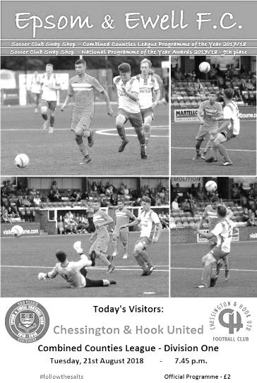
First half deficit too big to recover

It's fair to say that our opening home match of the season in front of a healthy number of spectators did not go particularly well as visiting Chessington & Hook United took advantage of an early red card to build a two goal lead, and although we nearly recovered the damage we weren't quite able to salvage the situation before time ran out on us.

Following their fine performances in Saturday's win at Bagshot, Scott Elgar and hat trick hero Taryn Smith were promoted into the starting eleven as were the returning Reisse Griffin and Bobby Bennett with Ryan Sullivan, Sean White, Mitch Sutherland and Liam Roberts dropping to the bench. They could all probably have had a claim to start this match, but with hindsight will probably be relieved that they weren't involved in an opening forty-five minutes that was considerably poorer than anything else produced this season so far.

We opened up brightly enough with a good chance in the fifth minute as Bennett sent a deep cross to the far post where Smith had time to chest the ball down and fire the ball across the goal, just a yard out, but unfortunately it was just out of reach of the incoming Kieran Campbell. This was followed by our first error of the day when a ball over the top of our defence resulted in the offside flag going up, but we didn't play to the whistle and Trey Maskini who was onside got through on the left. Fortunately we were able to recover the damage and sent the ball to the other end where Smith, clearly full of confidence, cut inside his man on the left and drilled a shot at goal which was just wide of Ian Hewitt's right hand post.

The game was looking well-balanced when everything changed. In the ninth minute Griffin played a square ball and it was intercepted. In a flash they sent the ball forward and Kieran Scantlebury was through on goal. Ricky Borrett came out and blocked the shot outside the area and after consultation with his Assistant, the referee sent him off. Ricky assures me that the ball hit him in the face and it then diverted onto his arm, so by that time it wasn't going towards goal, but the arms were up in what they would now deem an unnatural position and this may even have been the deciding factor in the red card. It was hard to complain with the referee's decision, and there was also little dissent from our players, which is often a telling factor. Whilst we were obviously down to ten men, we did at least have the security of Keiran Campbell going between the posts. He had played over fifty times for us in goal previously, so wasn't exactly a stranger to the position!

However, the visitors started to boss the game from this point. We had a half chance when good work between Elgar and Elliott Thompson at a short corner set up Lloyd Connelly who was a couple of feet over the bar with a strike from twenty yards, but with the clock in the 21st minute we conceded. A ball in from the left appeared to be a comfortable take for Campbell as he slid in to collect it, but it was spilled and Maskini then fed the ball in where Scantlebury was waiting. His first shot was superbly blocked by a defender, but the ball fell straight back to him and he made

no mistake with his second attempt from close range.

We were struggling to create much at this time and had a let off when a low shot from Aaron Fraser bounced off our post straight back to Campbell after 37 minutes, but we didn't heed the warning and two minutes later a slide rule pass into the channel cut us apart and allowed Maskini to stroll through and slot the ball past Campbell from close range.

At 2-0 down there were quite a few spectators at the match who thought it was game over, but all you can do is come out fighting and try to close the deficit. To our credit, the boys did just that. We did have a scare right at the start of the half when we pushed up after a corner, but someone had played three of their players onside; fortunately Jamie Watts ballooned his header over the bar and in the 51st minute we pulled a goal back as a right wing cross was met by a good header from Smith. It was heading for the top corner but Hewitt made an exceptional save to claw the ball out. Fortunately for us, Bennett was running in and tucked the loose ball away into the empty net.

We started to create more chances. Gone was the defensive openness and we began to make the opposition look quite ordinary, especially considering we were the team that were a player short. Scott Murphy had a shot deflected for a corner and from the short delivery, a clever pass from Elgar to Bennett finished with our striker finding the side netting when we had players in the danger area waiting for a tap in. Moments later we had another opportunity from a poor defensive clearance that ended when Murphy's cross was just too high for Bennett.

Sullivan and Roberts joined the fray and the latter hit a very powerful strike at goal which Hewitt did well to palm away for a corner. By and large though we still weren't quite getting it right up front. Maybe understandably so with the upheaval of playing a man short, but we kept working. Bennett scuffed a good chance into the other side netting this time and in the 89th minute a Roberts cross was met with a header from another substitute, Sean White. The header was a difficult one and he was unable to direct it on target, although you felt Smith would have hit the target had he called for it early enough as he was just behind him and unmarked, but of course White didn't know that.

As time ran down a Heagney free kick went straight into Hewitt's arms, and the final opportunity resulted in an unfortunate deflection onto Connelly and out for a goal kick. It sort of summed the match up really.

It would be too easy to blame this defeat on the early sending off, although some may choose to do just that and move on. However, if they did, it would be masking the poor display in that opening forty-five minutes when Chessington & Hook cut us open on far too many occasions and although we looked a lot tighter in the second half, the damage was done. Based on the performances in our opening three matches we could write this off as a freak result, and maybe we should, but that would be doing a disservice to the visitors who looked very good going forward and were deserving of the points, which it should be pointed out is their fifth win at Epsom in our last six home matches.

For our part, we have to pick ourselves up for two very prestigious matches coming up against Beckenham Town in the Emirates F.A. Cup and Lingfield in the Buildbase F.A. Vase. Maybe it's just as well after this performance that those two matches are away from home, where we still hold a perfect record.

Epsom and Ewell: Ricky Borrett, Adam Heagney, Reisse Griffin, Lloyd Connelly,
Steve Betancourt, Scott Elgar, Taryn Smith, Scott Murphy, Kieran Campbell,
Elliott Thompson, Bobby Bennett

Subs: Ryan Sullivan for Betancourt (66), Liam Roberts for Murphy (66),
Sean White for Elgar (75)

#
From behind the goal
Beckenham Town 2-2 Epsom & Ewell
Emirates F.A. Cup - Preliminary Round - Saturday 25th August 2018

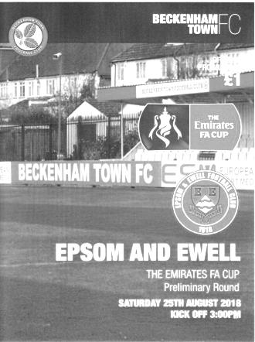
Salts hold Becks with the good, the bad and the brilliant from Roberts

Although this was our best performance of the season and the whole team contributed to this excellent result against our unbeaten Step Five opponents on their own patch, it is impossible to report on this encounter without referring frequently to our mercurial winger Liam Roberts who had a part in most of the key moments; scoring twice, hitting the post and also providing an assist for the opposition with an ill-advised back pass!

Following our disappointing outing at home to Chessington & Hook United there were three changes to the starting eleven. Reisse Griffin was unavailable, while Taryn Smith and Scott Elgar were back on the bench with Roberts and Ryan Sullivan reclaiming their starting positions and Sean White coming in at left back and having one of his best games in an Epsom shirt there.

Beckenham Town were our second Step Five opponents in this competition, following our 2-1 win at Langney Wanderers, and the match started in a similar way on a perfect surface, with the home team passing the ball around confidently while we found our feet but without any undue concern. In fact, the first chance of the match fell to us in the 6th minute when Scott Murphy ran at goal before setting up Roberts to the left of the goal with a good ball, but our man was a little off balance and he scuffed the ball wide of the near post from 10 yards out.

The home side had most of the ball in the early stages but were unable to put much pressure on and it was our boys who took the lead in the 25th minute. The goal in fact came from a Beckenham corner and it was fed out to the left where White slid the ball inside the full back and Roberts collected the ball and steered it out of reach of Michael McEntergart in the home goal and into the bottom corner from around the edge of the penalty area. It was a similar move to the second goal we had conceded on Tuesday evening, but this time it was our turn to benefit.

In fact it could have been 2-0 soon after. Kieran Campbell was fouled on the edge of the area and Murphy's free kick was low and to the keeper's left. Whilst he made a good save Campbell reached the loose ball first, but could only put the ball over the bar from ten yards out. Retribution was swift and in the 35th minute the home side equalised with a right wing delivery of real quality which was met by a powerful far post header ten yards out from Jamie Humphris that Ricky Borrett got a hand to but was unable to keep out.

As the half ended, the sun came out once again after providing us with a heavy downpour in the middle stages and we had an injury time scare when Steve Betancourt was dispossessed out on the Beckenham left and the ball came in quickly, being met with a good piece of control on the skiddy surface and fine shot, but Borrett was equal to it, making an acrobatic save and the teams went in at the half level.

The second half nearly opened with a stunning goal as White advanced into a central position, beat a couple of men and fizzed a shot from thirty yards that cleared the bar by a couple of feet with McEntergart beaten. A minute later Roberts was over the bar with a first time strike from an Adam Heagney cross and then Bobby Bennett found Campbell who squared the ball to White, but

from fifteen yards he was unable to keep the shot down. The early domination continued as Roberts picked up a loose ball and from just outside the area he drilled a shot that bounced back off McEntergart ‘s left hand post and then rebounded off the unaware keeper. On another day it might have gone in off him, but this time the ball stayed out and was cleared.

This was a superb start to the half so it came as a complete shock when Roberts was on the ball in a deeper position, but instead of playing it to White who was nearby, he sent it back to goal, where it was intercepted, leaving their player the easy task of squaring the ball to Richard Atkins who finished easily to give the home side an undeserved lead.

This was ever so harsh, but par for the course in our F.A. Cup exploits over the years and mentally, quite a few supporters probably began to prepare themselves for another entry in the catalogue of heroic defeats. However, there was plenty of time remaining and Neil Grant made a double substitution with Taryn Smith and Scott Elgar coming on for the tiring Elliott Thompson and the limping Campbell. We continued to dominate and Bennett was next through on goal on the hour, but from a wide angle McEntergart blocked his low effort that was going just inside the near post.

Roberts tried his luck from distance but sliced the shot a little and it went wide from twenty yards. A few minutes later he earned a corner with a blocked shot but his set piece caused controversy as it skipped past some players before hitting the arm of a defender. It certainly looked like a penalty but it was one of those where the referee might have been expecting an intervention from the Assistant and when it didn't come, he maybe didn't feel confident enough to award the spot kick on his own. White nearly scored again when his cross cum shot just crept past the far post but finally the pressure told in the 74th minute. Sullivan played a very similar pass to White's in the first half and Roberts was in on goal again. This time though, he cut back onto his right foot and literally thumped it into the top corner from 18 yards for one of the goals of the season so far.

White nearly got through again as we continued to press before Bennett was played through on goal after Smith was fouled, only for the break to be pulled back by a referee who blew the whistle too soon without waiting to see if an advantage would develop.

The final ten minutes were more even as the home side got back into the match for a while. A deep delivery from the right wing was met by another Humphris header but Borrett was down low to make the save before another right wing delivery skipped past everyone in our area and away to safety. There was time for another incident when Murphy was deemed to have won the ball but the home player took offence and went aggressively towards our Captain, who then stood up and in the process pushed him away. I felt that their man should have had a booking, yet Murphy was the only player the referee even spoke to!

Moments later Callum McGeehan went through the back of Bennett with no comeback, although in the final moments Heagney picked up a yellow card for an unnecessary challenge which gave the home side a chance to clinch the match. Only Ike Robertson will know how close he was to clinching the tie as the delivery to the far post looked like it was just right for him, but it went past him and the chance to win the match at the first attempt was gone for both sides.

This was a good advert for football with both teams playing some nice stuff, on an admittedly superb surface which got even better once the rain had come down on it, and we are both in the hat for the next round which is exciting in itself. I just hope that our best chance of success hasn't gone yet and we can put the same level of performance up in Tuesday evening's replay at Chipstead. If we can, the replay could be a cracker!

Epsom and Ewell: Ricky Borrett, Adam Heagney, Sean White, Lloyd Connelly, Steve Betancourt, Ryan Sullivan, Taryn Smith, Scott Murphy, Kieran Campbell, Elliott Thompson, Bobby Bennett

Subs: Scott Elgar for Thompson (60), Taryn Smith for Campbell (60)

This Day in History - 28th August
Date | Day | Competition |  | Opponents |  | Scorers
28/08/26 | Sat | Friendly | H | Millwall United | 4-3 | R.Marlow (2), J.Parr, W.Challis
28/08/37 | Sat | London League  Cup 1 | H | Tilbury | 1-1 | J.Jones
28/08/48 | Sat | London League  Cup 1 | A | Bedford Town Reserves | 1-2 | T.Rochester
28/08/54 | Sat | Corinthian League | H | Yiewsley | 0-4
28/08/57 | Wed | Corinthian League | A | Yiewsley | 0-3
28/08/65 | Sat | Athenian League 2 | A | Rainham Town | 1-0 | J.Wand
28/08/67 | Mon | Athenian League  Division 2 Cup 1 | H | Eastbourne | 2-1 | T.Stafford, C.Kelly
28/08/71 | Sat | Athenian League 2 | A | Edgware Town | 0-2
28/08/72 | Mon | Athenian League 2 | H | Eastbourne Town | 2-1 | P.Long (2)
28/08/76 | Sat | Athenian League 1 | H | Grays Athletic | 3-0 | J.Eales, T.Coombe, T.Tuite
28/08/78 | Mon | Isthmian League 1 | A | Aveley | 1-0 | T.Tuite
28/08/79 | Tue | Isthmian League Cup 1 | A | Corinthian Casuals | 7-0 | T.Tuite (3), R.Beswick (3), T.Pommell
28/08/82 | Sat | Isthmian League 1 | A | Maidenhead United | 0-3
28/08/84 | Tue | Isthmian League  Premier Division | A | Wycombe Wanderers | 0-0
28/08/93 | Sat | F.A. Cup  Preliminary Round | A | Hailsham Town | 4-1 | N.Webb, R.Purvis, M.Esiri, T.Smith
28/08/96 | Wed | Isthmian League Cup Preliminary Round | H | Wivenhoe Town | 3-2 | S.Miller (2), A.Boxall
28/08/99 | Sat | Isthmian League 3 | A | East Thurrock United | 4-0 | S.Miller, S.Hatton, P.Bunter, B.Stevens
28/08/04 | Sat | Isthmian League 2 | H | Abingdon Town | 5-4 | R.Ingham (2), M.Owen (2), C.Read
28/08/05 | Sun | F.A. Cup  Preliminary Round | H | AFC Newbury | 6-1 | J.Goodwin (2), L.Jones, R.Ingham, A.Stones, C.Read
28/08/06 | Mon | Combined Counties Premier Division | A | Chessington & Hook United | 1-1 | P.N'gbale
28/08/10 | Sat | F.A. Cup  Preliminary Round | H | Flackwell Heath | 3-2 | C.West, R.Bedj Bedj, M.Jarman
28/08/17 | Mon | Combined Counties Premier Division | A | Banstead Athletic | 1-1 | K.Hough

History Corner – 28th August
81 years ago we hosted Tilbury in the London League Cup, drawing 1-1 at West Street with Jimmy Jones netting for us. This however, was only the beginning of the story. The replay would take place in November at Tilbury’s old Orient Field ground but again the teams could not be separated, drawing 3-3 after extra time. In these non-floodlight days, this caused real havoc to the fixture list and although Epsom won the second replay in February 1938 by the surprisingly comfortable margin of eight goals to one, there was no time to play the Semi-Final and the competition would get held over to the following season! We would eventually reach the Final.

46 years ago we defeated Eastbourne 2-1 in an Athenian League match with the ill-fated Paddy Long scoring both goals. It was our first win of the season, but more relevantly it was our first home win in seventeen attempts in all competitions and our first for an incredible 376 days, which is maybe unsurprisingly a club record! Relegation would follow in 1973 but great things would occur that pivotal summer, without which we wouldn’t be here now. (see programme pictured)

39 years ago we were drawn at Corinthian Casuals in the Isthmian League Cup, but they were unable to host the fixture and it was switched to West Street, which they must have regretted as we crushed them 7-0! Tommy Tuite and Roy Beswick both scored hat tricks while Tony Pommell got the other one and we would reach the last 16 that year.

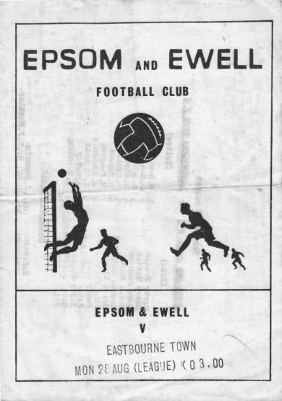
34 years ago we visited Loakes Park for our very first away match in the Isthmian League Premier Division, a daunting task, but we secured a fine 0-0 draw there. On a personal note, I remember reading the programme at half time that day, which told me that Epsom had played there once before in front of 7,000 people in the Amateur Cup and it was this solitary fact that got me really intrigued and started my own long road to chart our club history, which will in around three years make our website the largest online non-league club history record in the country.

25 years ago we played our first ever F.A. Cup match on this date when we travelled to the South coast for a meeting with Hailsham Town. There we gained a 4-1 win to earn a measure of revenge for our last 16 F.A. Vase defeat from four years previously. Ironically we then travelled to Gravesend & Northfleet who defeated us 3-0 to take their own revenge for our superb win there in the F.A. Trophy in 1982, when they had been an Alliance Premier League club.

19 years ago we defeated East Thurrock United 4-0 on their own Rookery Hill ground with goals from Stuart Miller, Simon Hatton, Paul Bunter and Barry Stevens. This would be their only defeat at home that season as they would go on to win the title, even though we also beat them 2-1 at home for good measure. We never met again and they now play at Step Two.

13 years ago we hosted AFC Newbury in a Sunday F.A. Cup tie at Merland Rise and bashed them up by six goals to one with Jamie Goodwin scoring twice on his debut. Other goals came from Luke Jones, Richard Ingham, Adam Stones and Chris Read but the run ended in disappointing fashion in the next round at Camberley Town by the only goal after dominating the match and only eighteen days after we had won there 3-0!

8 years ago we trailed at Moatside, home of Merstham FC against Flackwell Heath in the F.A. Cup but turned the match around to win 3-2 with goals from Charlie West, Ramzi Bedj Bedj and Mark Jarman. Incidentally Mark became a father for the first time just over a week ago now and we send our congratulations to Mark and Cassie and the proud grandparents Gary and Gemma.

Combined Counties League Premier Division
Opponents All-time Records
inc Saturday  25th August | P | W | D | L | F | A | PPG | GD | Best  Win | Worst  Loss
Bedfont & Feltham | 2 | 2 | 0 | 0 | 13 | 3 | 3.00 | +10 | 9-2 | -
Bagshot | 1 | 1 | 0 | 0 | 3 | 0 | 3.00 | 0 | 3-0 | -
Frimley Green | 10 | 8 | 1 | 1 | 32 | 5 | 2.50 | +27 | 7-1 | 0-1
Sheerwater | 4 | 2 | 2 | 0 | 8 | 2 | 2.00 | +6 | 3-0 | -
Godalming Town | 3 | 2 | 0 | 1 | 4 | 5 | 2.00 | -1 | 2-1 | 0-3
Farnham Town | 17 | 9 | 4 | 4 | 30 | 25 | 1.82 | +5 | 3-0 | 1-4
Ash United | 19 | 10 | 3 | 6 | 48 | 31 | 1.74 | +17 | 6-0 | 0-3
Chessington & Hook | 29 | 12 | 9 | 8 | 59 | 44 | 1.55 | +15 | 6-0 | 1-3
Cove | 34 | 15 | 9 | 10 | 75 | 55 | 1.59 | +20 | 7-0 | 1-6
Sandhurst Town | 15 | 6 | 0 | 9 | 27 | 28 | 1.20 | -1 | 4-0 | 1-3
AC London | 0 | 0 | 0 | 0 | 0 | 0 | 0 | 0 | - | -
British Airways | 0 | 0 | 0 | 0 | 0 | 0 | 0 | 0 | - | -
Dorking Wanderers Res | 0 | 0 | 0 | 0 | 0 | 0 | 0 | 0 | - | -
Eversley & California | 0 | 0 | 0 | 0 | 0 | 0 | 0 | 0 | - | -
FC Deportivo Galicia | 0 | 0 | 0 | 0 | 0 | 0 | 0 | 0 | - | -
Fleet Spurs | 0 | 0 | 0 | 0 | 0 | 0 | 0 | 0 | - | -
Kensington Borough | 0 | 0 | 0 | 0 | 0 | 0 | 0 | 0 | - | -
Tooting Bec | 0 | 0 | 0 | 0 | 0 | 0 | 0 | 0 | - | -

CCL Division One Club Directory
AC LONDON: Telephone: 0208 660 5491 - Colours: Orange/Black/Black
Ground: Whyteleafe FC - 15 Church Road, Whyteleafe. CR3 0AR

ASH UNITED: Telephone: 01252 344264 - Colours: Green with Red Trim/Green/Green
Ground: Shawfields Stadium, Youngs Drive, Shawfields Road, Ash, Aldershot. GU12 6RE

BAGSHOT: Telephone: 01252 623804 - Colours: Yellow/Black/Black
Ground: Fleet Town FC - Calthorpe Park, Crookham Road, Fleet. GU51 5FA

BEDFONT & FELTHAM: Telephone: 0208-890 7264 - Colours: Yellow/Blue/Blue

Ground: The Orchard, Hatton Road, Bedfont. TW14 9QT

BRITISH AIRWAYS: Telephone: 0208-890 7264 - Colours: Sky Blue/Navy Blue/Navy Blue
Ground: Bedfont & Feltham FC - The Orchard, Hatton Road, Bedfont. TW14 9QT

CHESSINGTON & HOOK UNITED: Telephone: 01372-602263 Colours: All Blue
Ground: Chalky Lane, Chessington. KT9 2NF

COVE: Telephone: 01252 543615 Colours: Yellow/Black/Black
Ground: Oak Farm, Squirrel Lane, Cove GU14 8PB

DORKING WANDERERS RES Telephone: 01306 400151 - Colours: Red & White Stripes/ Blue/ Red
Ground: Meadowbank Stadium, Mill Lane, Dorking. RH4 1DX

EPSOM & EWELL Telephone: 01737-553250 - Colours: Royal Blue & White Hoops/Royal Blue/Royal Blue - Ground: Chipstead FC, High Road, Chipstead. CR5 3SF

EVERSLEY & CALIFORNIA Telephone: 0118 973 2400 - Colours: - White & Royal Blue Hoops /Royal Blue/ Royal Blue - Ground: Fox Lane, off Reading Road, Eversley. RG27 0NS

FARNHAM TOWN Telephone: 01252 715305 - Colours: - Claret & Sky Blue /White/ Claret & Blue
Ground: Memorial Ground, Babbs Mead, West Street, Farnham. GU9 7DY

FC DEPORTIVO GALICIA Telephone: 0208 831 9067 - Colours: Royal Blue/Royal Blue/White
Ground: Bedfont Sports FC - Bedfont Sports Club, Hatton Road, Bedfont. TW14 9JR

FLEET SPURS Telephone: 01252 662810 - Colours: Dark Blue with Red Trim/Dark Blue/Dark Blue
Ground: Kennels Lane Farnborough. GU14 0ST

FRIMLEY GREEN Telephone: 01252 835089 - Colours: All Blue
Ground: Frimley Green Recreation Ground, Frimley Green Road, Frimley. GU16 6JY

GODALMING TOWN Telephone: 01483 417520 - Colours: Yellow/Green/Yellow
Ground: Wey Court, Meadrow, Godalming. GU7 3JE

KENSINGTON BOROUGH Telephone: 01372 360151 - Colours: All Blue
Ground: Leatherhead FC – Fetcham Grove, Guildford Road, Leatherhead. KT22 9AS

SANDHURST TOWN Telephone: 01252 878768 - Colours: Red & Black Stripes/Black/Black
Ground: Bottom Meadow, Sandhurst Memorial Park, Yorktown Road, Sandhurst. GU47 9BJ

SHEERWATER Telephone: 01483 772470 - Colours: Royal Blue & White/Royal Blue/Royal Blue
Ground: Woking FC - Laithwaite Community Stadium, Kingfield, Kingfield Road, Woking. GU22 9AA

TOOTING BEC Telephone: 0208 540 8843 - Colours: Black & White Stripes/White/White & Black
Ground: Raynes Park Vale FC – Prince George’s Playing Fields, Grand Drive, Raynes Park. SW20 9DZ

Centre page for results

Centre page for results

Epsom & Ewell - F.A. Cup Facts & Figures
Today is Epsom & Ewell’s 175th F.A. Cup match!

In that time, we have a record of: Won 68 Drawn 23 and Lost 83 with a Goal Difference of F 308 A 374 - minus 66.

We first entered the F.A. Cup in 1925/26; our second season as a Senior status club, when a missed penalty from our Captain Sid Bristow was costly in a 1-0 defeat to West Norwood, played at their temporary ground in Streatham Road.

Following another first hurdle loss in 1926/27, our first win came on 17th September 1927 when we beat Mitcham Wanderers 3-2 with the first goal that day from Jack Parr (see picture below).


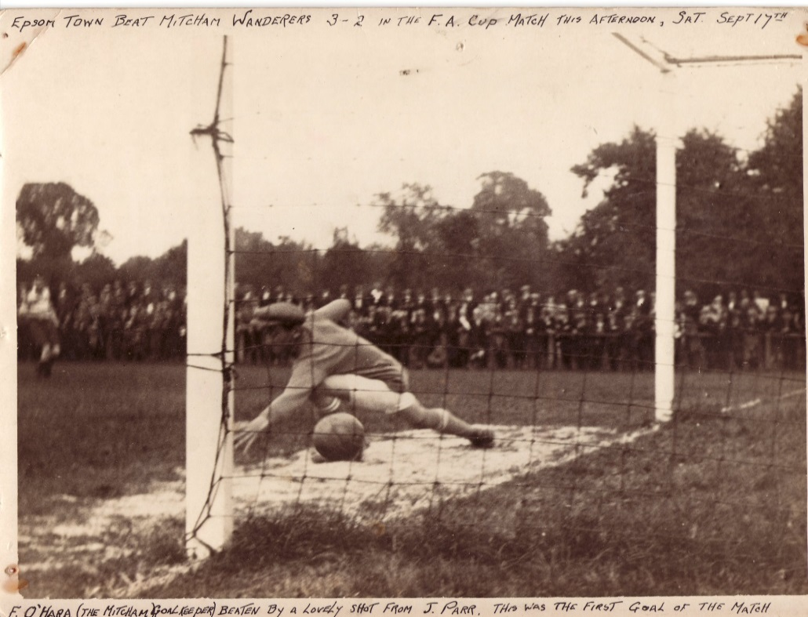
We have reached the First Round Proper on only the one occasion, way back in 1933 when we were defeated 2-4 by Clapton Orient at the Lea Bridge Stadium (see programme across page). However, we have reached the fourth qualifying round on one other occasion in 1980 when being beaten 5-0 by a very good Enfield side that would go on to reach the Fourth Round of the competition that year (last 32).

In addition to those two successful seasons, we have reached the third qualifying round on eight other occasions, in 1927 and 1929 when we lost to Wimbledon, 1932 when we

were defeated at Imber Court by the Met Police, in 1955 when a half time lead turned into a 3-1 home defeat against Margate, in 1964 when Slough Town won 1-0 at West Street, in 1976 when the Isthmian League Champions Enfield required a replay to defeat us, in 1981 when Hastings United won 4-2 at Ewell, and in 1984 when Bognor Regis won a topsy-turvy game 5-4 and went on to reach the Second Round Proper themselves.

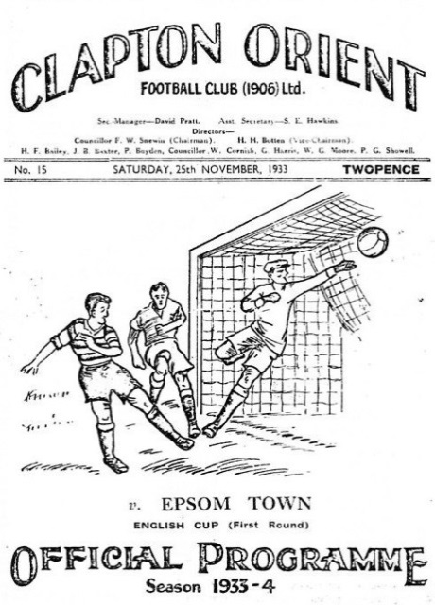
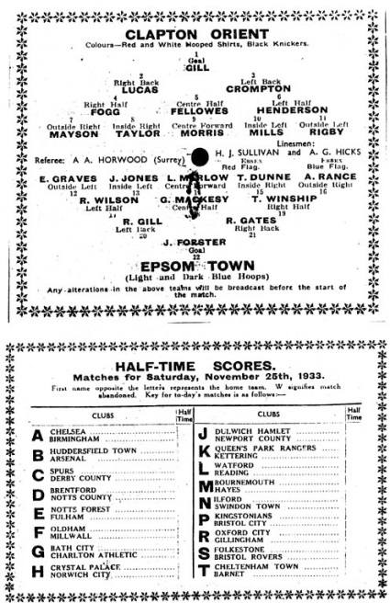
The last time we went as far as the Second Qualifying round was back in 2000 when Horsham defeated us 5-1 at Queen Street. Since that time we have only reached the First qualifying round on five occasions; in 2001 when we crashed 5-0 at Bedfont’s Orchard ground, in 2005 when we lost 1-0 at Camberley, in 2008 when Burgess Hill defeated us 5-2, in 2010 when Hythe Town beat us 2-0 on the way to a First Round appearance at Hereford United, and most recently in 2012 when wins over Arundel and Three Bridges earned us a trip to Bognor Regis where we were beaten 4-0.

Of the ties played so far, we have been at home on 89 occasions and away on 84 with one match, a second replay against Southall & Ealing Borough being played at Dulwich Hamlet’s old Champion Hill ground, when we were beaten 5-1. This was the last match played for the club by Trevor Lee and Phil Walker before joining Millwall in 1975.

When I first wrote this summary I advised that replays haven’t come around too often in recent years, but tonight’s is our third in recent years, with Whyteleafe in 2013/14 and Croydon in 2014/15 being the others. Our loss to Erith & Belvedere in 2015 ensured that the mid-seventies (1975-77) remains the last time that we have had replays in three successive years. Unfortunately, the last replay we actually won was at Imber Court way back in 1989 when we defeated Met Police 2-0. We don’t have many goalless

draws either, with just three in total; at Nunhead in 1932, at Whitstable Town in 1954 and at home to Met Police in 1989.

Our biggest F.A. Cup win came in 1964 when we defeated Marlow 7-1, although we do also have an 8-3 win against Beddington Corner in 1929 and a 6-0 win over the Amateur Guildford club in 1949. Conversely we lost 10-1 at Kingstonian in 1947, 0-8 at home to the great Walthamstow Avenue side in 1963, 7-0 at arguably the best non-league side in the country at the time, Barnet in 1988, 8-1 at home to Woking in 1945, and 7-1 twice; at Wimbledon in 1929 and at home to Crowborough Athletic in 2007. Equally concerning is the fact that we haven’t kept a clean sheet in any F.A. Cup tie in the last eighteen matches, having to go back to a 3-0 win over Shoreham in our first home game at Merstham in 2010.

In terms of attendances, the largest, maybe unsurprisingly was 9,485 at Clapton Orient in 1933 and this is followed by 7,631 at Plough Lane in 1927 and just under 7,500 at the same venue two years later. We had an incredible 5,000 at West Street for the visit of Kingstonian in 1949 (pictured below), 4,600 when we hosted Sutton United in 1937, and finally 4,000 at our old ground for the win over Dorking in 1955.

So which player has played the most times for Epsom in the F.A.Cup? It was “Brother” George Mackesy our Captain throughout the glory years of the thirties played in most with 32. Tommy Tuite was just behind him with 31, and the long-serving legend Dick Wilson played in 26,

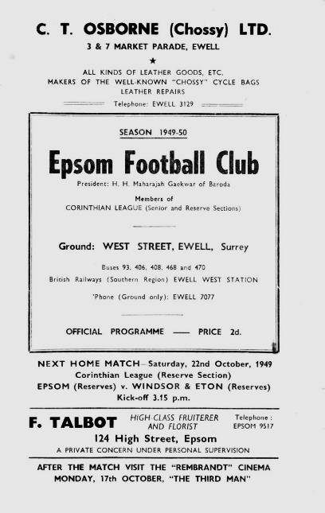
Recent players come nowhere near this. Dale Marvell leads the way with 16, and holds the record for years between F.A. Cup goals as he found the net for us at Moneyfields back in 2000 but didn’t score again in Epsom colours until our 2014/15 win at Hassocks; a gap of just under 14 years! Kyle Hough is next with 13 appearances, with Ben Hayward on 11, while former Captains Jamie Hatfield and Alex Rodrigues have appeared in ten and nine respectively and Alex McGregor also has nine.

For goal scoring, Tommy Tuite comes second again as his tally of 16 is beaten by the second greatest scorer in our history, Reg Marlow with 18. Tommy Dunne and Leslie Marlow are next with 11, Billy Williams and Jack Parr scored nine each while Jimmy Jones and Steve Hill both scored eight. From our recent players it is Mark Jarman who has four goals, ahead of Robbie Burns with three and Jamie Summers, Ramzi Bedj Bedj, Kyle Hough, Daryl Cooper-Smith, Tom Neale, Charlie West and now Liam Roberts with two. Hopefully we can add some more Epsom scorers to this list tonight!

A few words from…
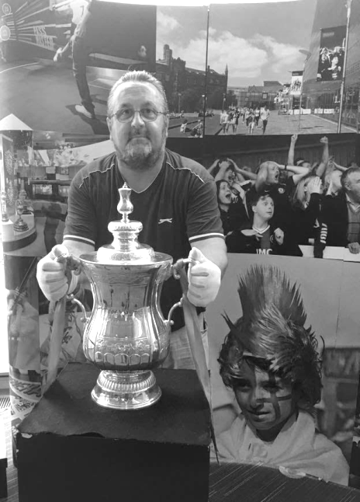
My name is Andy Phillips, and I'm at the game tonight as part of my 'Road to Wembley'.

For those unfamiliar with my project, I will explain.

The challenge is to pick a team in the F.A. Cup Extra Preliminary Round, and then attend all their matches in the competition until they get knocked out. You then follow the victors onwards, and so on until the final at Wembley.

It's not an easy challenge, and you obviously need to be committed to any potential replays, postponements and difficulties obtaining tickets in the later stages.

This is actually my third consecutive season on the 'Road to Wembley'.

I started in 2016/17 with my local team Erith Town, and got all the way through to see Arsenal lift the trophy.

Highlights that season were seeing Adam Coombes score a double hat trick for Welling United in a 7-1 win against Swindon Supermarine, Stourbridge beating Northampton Town, and Wycombe Wanderers narrowly losing 4-3 at White Hart Lane.

The greatest honour though, was to have my journey profiled in the F.A. Cup Final programme.

I enjoyed it so much, that I didn't want the journey to end. So I chose the nearest team to Arsenal (Tower Hamlets) to continue with last season.

Remarkably I managed to complete it again, along with a F.A. Trophy 'Road to Wembley' as well. I was very lucky that none of my matches clashed, and amazingly again my 'double' was featured in the Cup Final programme.

With Chelsea winning, it meant that this season I started with the nearest team to Stamford Bridge, which was Colliers Wood United. Wood managed an honourable draw at Beckenham Town in the last round, but bowed out at home in extra time. So now I'm following Becks onwards, until they get knocked out.

Best of luck for both teams tonight, but rest assured that whoever wins, I'll be watching their 1st Qualifying Round game and maybe even further!

Anyone who is interested can follow Andy’s journey on Twitter at @APCAFC.

Beckenham Town History

FIRST AFFILIATED IN 1887
Beckenham Town Football Club is one of the older non-league clubs still in existence, being first affiliated to The Kent Football Association in 1887. Records show the club played in the London League from 1923 to 1933 and 1951 to 1961 and the Aetolian League from 1961 to 1964 before moving to the Greater London League from 1964 to 1969. In addition to its present-day participation in the FA Cup and FA Vase, it also competed in the FA Amateur Cup from 1926 to 1967.

“NEVER HAD IT SO GOOD”
Amongst the club’s past Presidents is ex-Prime Minster the Rt. Hon Harold Macmillan MP and amongst the club’s Vice Presidents is Sydney Wooderson one of Britain’s
greatest middle-distance runners.

SPEND IT LIKE BECKENHAM
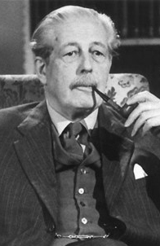
In July 1980 Beckenham moved from Stanhope Grove to their present ground in Eden Park Avenue joining the Kent League in 1982-83. In 2003 Beckenham were awarded £100,000 by the Football Foundation for ground improvements which enabled the ground to become enclosed and their award winning pitch along with a drainage system to be laid.

TROPHY SUCCESS AT LAST
Honours include the London League Championship in 1927-28 and runners-up in 1930-31. Unfortunately, the club folded in 1969 merging with Bromley FC. The club was subsequently re-formed and joined London Spartan League in 1975 and enjoyed some early success being Runners-up to Fisher Athletic in the Spartan League Senior Division in 1977-78. Town also reached two Spartan League Cup Finals, losing to Welling United and Farnham Town. More recent successes have been two previous appearances in the Kent League Cup Final in 1984-85 and 1992-93 and Runners-Up to Maidstone Utd in the Kent League Premier Division in 2005-06.

The season, after three previous unsuccessful attempts in 1981-82, 2004/05 and 2007/08, finally victory in the Kent Senior Trophy after a 4-0 win over Ashford Utd at Longmead Stadium in April 2014 and in May of the same season the SCEF League Cup with a 2-0 Win against Corinthians at Bromley Stadium. (see picture across page)

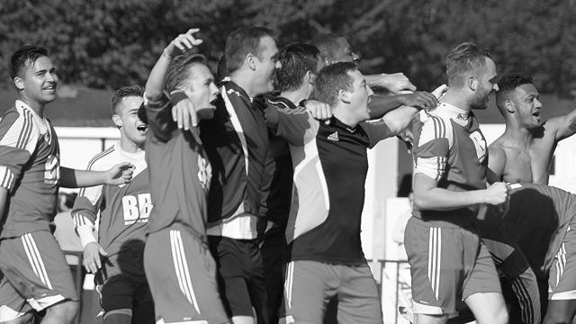
THE FUTURE
After a couple of strange seasons where relegation was pretty much avoided on the last day of the season to then be followed up with a promotion push which just came up short in the last few weeks of the season the club are now building a strong squad of players that will provide stability, experience and quality that will see them challenging for promotion and the league title.

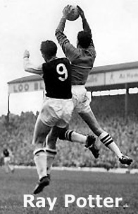
PAST PLAYERS
Amongst Becks ex-players are
goalkeeper Ray Potter who played over 220 games
for West Bromwich Albion ,
Frank “Dot” Morris who played over 70 games
for Crystal Palace and
Pat Saward who played for Aston Villa in the 50’s and
captained The Republic of Ireland.
More recently ex-Charlton Athletic star
Jason Euell wore Beckenham’s colours.

Scouting the Opponent – Beckenham Town

On Saturday we played our first competitive match at Beckenham Town’s Eden Park Avenue ground. We had gone there for a friendly on their adjacent pitch in 1983/84, winning 1-0, but our last competitive visit was at their previous ground in Stanhope Grove on 20th October 1979 when we won 2-0 in a London Senior Cup tie, having lost in the same competition by the only goal there two seasons previously.

We have met twice since then, winning 5-1 on 16th February 1988 in another London Senior Cup tie which was switched to West Street as Beckenham Town didn’t have lights at the time. Our last encounter came in the Surrey Senior Cup on a freezing Thursday night on 30th December 2010 at our temporary Moatside home, losing 2-3.

We also played a former Beckenham team in the early thirties in London League action at which time they were based at Balmoral Avenue; a stone’s throw from their old Stanhope Grove site, but almost certainly on a different pitch. They were the original Beckenham F.C. and existed from 1887 to 1969 by which time they had relocated to Stanhope Grove. The club reformed in 1971 at the same venue but moved to Eden Park Avenue in 1980.

Nowadays they play in the Southern Counties League East where they finished fourth in 2017/18 and are currently unbeaten this season. To reach this stage they defeated Colliers Wood United 2-0 after extra time at Wibbandune after a 1-1 draw at Eden Park Avenue.

Southern Counties East League Premier Division Table
incl Monday 27th August | P | W | D | L | F | A | Pts | GD
Chatham Town | 5 | 4 | 1 | 0 | 14 | 5 | 13 | +9
AFC Croydon Athletic | 5 | 4 | 1 | 0 | 10 | 3 | 13 | +7
Lordswood | 6 | 3 | 2 | 1 | 13 | 10 | 11 | +3
Corinthian | 5 | 3 | 1 | 1 | 8 | 6 | 10 | +2
Beckenham Town | 3 | 3 | 0 | 0 | 7 | 3 | 9 | +4
Canterbury City | 4 | 3 | 0 | 1 | 11 | 8 | 9 | +3
Deal Town | 5 | 2 | 2 | 1 | 10 | 8 | 8 | +2
Cray Valley (PM) | 4 | 2 | 1 | 1 | 14 | 9 | 7 | +5
Fisher | 5 | 2 | 1 | 2 | 8 | 6 | 7 | +2
Glebe | 5 | 2 | 1 | 2 | 5 | 6 | 7 | -1
Sheppey United | 5 | 2 | 0 | 3 | 10 | 7 | 6 | +3
Punjab United | 6 | 1 | 3 | 2 | 11 | 11 | 6 | 0
Hollands & Blair | 5 | 2 | 0 | 3 | 5 | 8 | 6 | -3
Crowborough Athletic | 5 | 2 | 0 | 3 | 5 | 13 | 6 | -8
Erith Town | 4 | 1 | 2 | 1 | 8 | 8 | 5 | 0
K Sports | 4 | 1 | 1 | 2 | 7 | 8 | 4 | -1
Bearsted | 4 | 1 | 0 | 3 | 8 | 11 | 3 | -3
Rusthall | 5 | 1 | 0 | 4 | 5 | 14 | 3 | -9
Croydon | 4 | 0 | 0 | 4 | 5 | 11 | 0 | -6
Tunbridge Wells | 5 | 0 | 0 | 5 | 4 | 13 | 0 | -9

EL Records Premier Challenge Cup
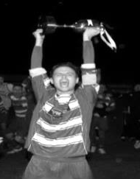
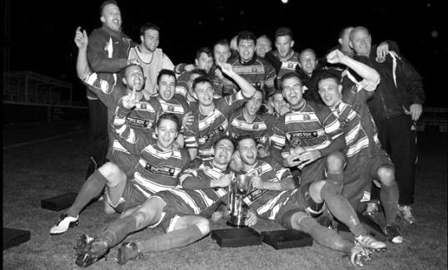
First Round
Camberley Town | 18/9 | Cobham
Horley Town | 18/9 | Chertsey Town
Badshot Lea | 25/9 | Walton & Hersham
FC Deportivo Galicia | 12/9 | Cove
Chessington & Hook United | 18/9 | AFC Hayes
Farnham Town | 18/9 | Southall
Hanworth Villa | 18/9 | Kensington Borough
Second Round
Bedfont & Feltham | 25/9 | Tooting Bec
Sheerwater | 18/9 | Balham
Ash United | 4/9 | Fleet Spurs
Frimley Green | 25/9 | Guildford City
Godalming Town | 25/9 | Dorking Wanderers Reserves
Abbey Rangers | 25/9 | Redhill
FC Deportivo Galicia / Cove | V | AC London
Camberley Town / Cobham | V | Chessington & Hook / AFC Hayes
CB Hounslow United | V | Badshot Lea / Walton & Hersham
Hanworth Villa / Kensington Borough | V | Sandhurst Town
Epsom & Ewell | 25/9 | Bagshot
Sutton Common Rovers | V | Farnham Town / Southall
Horley Town / Chertsey Town | V | British Airways
Eversley & California | 25/9 | Knaphill
Banstead Athletic | 25/9 | Colliers Wood United
Spelthorne Sports | 25/9 | Raynes Park Vale

Match and Ball Sponsorships – 2018/19
Opponent | Date | Match Sponsor | Ball Sponsor
Chessington & Hook Utd | 21/08/18 | Club President - Stella Lamont
Beckenham Town (FAC) | 28/08/18 | Building Shop Ltd
Cove | 08/09/18 | EEFC Management Committee
Tooting Bec | 18/09/18
Bagshot (LC) | 25/09/18
Sheerwater | 06/10/18
Frimley Green | 03/11/18
Kensington Borough | 17/11/18
Dorking Wanderers Res | 27/11/18
Godalming Town | 01/12/18
Bedfont & Feltham | 08/12/18
Eversley & California | 29/12/18
Ash United | 12/01/19
Bagshot | 19/01/19
Farnham Town | 02/02/19
British Airways | 16/02/19
AC London | 02/03/19
FC Deportivo Galicia | 12/03/19
Fleet Spurs | 06/04/19
Sandhurst Town | 20/04/19 | Club President - Stella Lamont
Sandhurst Town (LD1C) | tba
Unknown
(Surrey Premier Cup)
Match sponsorship costs just £60.00!

Sponsorship includes:

Admission, programmes and hospitality for three people.

A full page advert in the programme and mascot for the day (if required).

If you are interested, just speak to a Committee Member,
or drop me an email at: richard.c.lambert@gmail.com


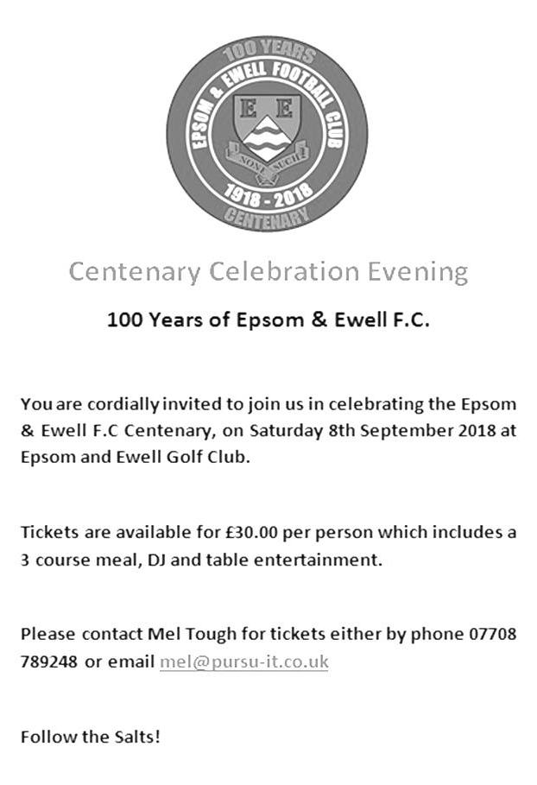
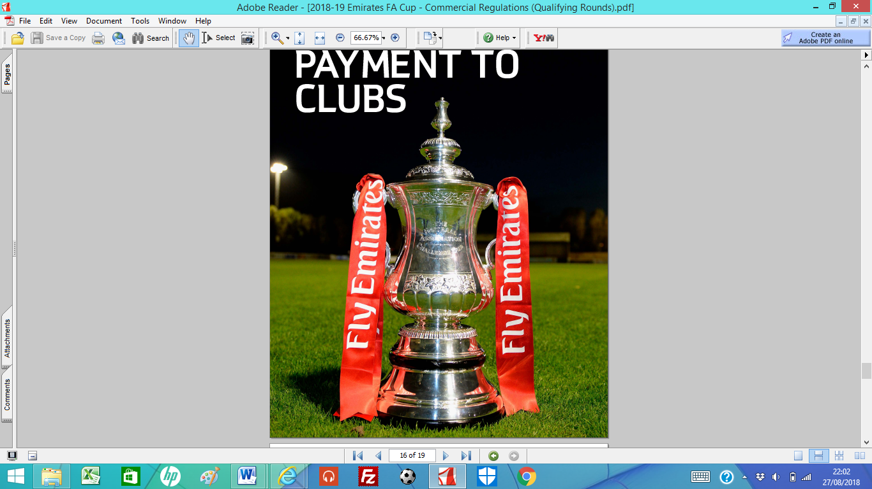

Emirates F.A. Cup – Preliminary Round Replay
Tuesday, 28th August 2018 - Kick-off 7.45 p.m.
Epsom and Ewell  (Royal Blue & White hoops) | V |  | Beckenham Town  (All Red)
Squad | NUMBERS |  | Squad
Ricky Borrett |  |  | Michael McEntegart
Adam Heagney |  |  | Danny Fitzsimons
Sean White |  |  | Callum McGeehan
Lloyd Connelly |  |  | Nathan Paul
Steve Betancourt |  |  | Jack Hope
Ryan Sullivan |  |  | Eku Dean
Liam Roberts |  |  | Stefan Wright
© Scott Murphy |  |  | Richard Atkins
Kieran Campbell |  |  | Jamie Humphris
Elliott Thompson |  |  | IkeRobinson
Bobby Bennett |  |  | Jesse Darko
Reisse Griffin |  |  | Adam Wadmore
Taryn Smith |  |  | Shameek Farrell
Mitch Sutherland |  |  | Jason Mensah
Alex McKay |  |  | Josh Owen
Luke Elgar |  |  | James Duckworth
Ben Dyson |  |  | Dean Carpenter
Endrit Dobraj
Stuart Russell
Jay Bateman
Louis O’Brien
George Gill
Shaun Masterson
Neil Grant | MANAGER |  | Jason Huntley
Simon Funnell | ASSISTANT
Sam Morgan / Alex McKay | COACHES
REFEREE: R. Morris
ASSISTANTS: R. Wells, A. Del Maschio
Today’s Match and Match Ball are sponsored by:
Building Shop Ltd – their adverts are on our website

OUR NEXT VISITORS TO HIGH ROAD (depending on F.A. Cup progress)
Cove
Cherry Red Combined Counties League – Division One
Saturday, 8th September 2018

